|  |  |  |
| --- | --- | --- |
| **Problem Chosen** F | **2021 MCM/ICM Summary Sheet** | **Team Control Number 2113256** |

**The Assessment and Improvement Methods of Higher Education System Based on The Economy Development**

**Summary**

This article provides a method to evaluate the healthy and sustainable state of national advanced education system, and a series of models to explain and address the problems of Chilean higher education system.

First, we defined the criterion of sustainability and health for higher education system, then we built **Advanced Education System Development index** (AED index) to qualify criterion based on 21 university’s research. Moreover, we applied our index to evaluate and compare different countries’ higher education system. For some subfactors, we used **Analytic Hierarchy Process** (AHP) to determine weight.

Second, based on **Lewis' development economic model** – **Two sector model,** we explore the relationship between higher education system and economy development. Then we introduced **Optimization theory** to find the most optimal point $ξ^{*}$ which helpful to achieve economic prosperity and fully employment.

Third, we pointed out the two biggest difficulties for Chile education reform – market failure and inequity. For market failure, we use difference equation to explain the reason and process. As for inequity, we think the root of education inequity is income inequality, so we introduced **Alternative minimum tax** to deal with this problem.

Finally, we set up a **timeline** of our policies implantation, and in this process, some possible post-implementation scenes are described in detail.

**Keywords: Development Economics, Higher Education Assessment, Education Equity, Economic Prosperity, Employment**

Contents

1 Introduction 3

1.1 Problem Background 3

1.2 Restatement of the Problem 3

1.3 Our Work 4

2 Assumptions and Justifications 4

3 Notations 5

4 Advanced Education Development Index [AED Index]: 5

4.1 The Establishment of AED Index 5

4.2 Application of AED Index 7

5 Two-sector Model 8

5.1 The Establishment of Two-sector Model 8

5.2 The Solution of Model : 11

5.3 Model Analysis 12

6 The Difference Equation in Labor Market 12

6.1 The Establishment of Two-sector Model 12

6.2 The Solution of Model : 14

6.3 Model Analysis 14

7 The Tax Policy 14

8 Implementation Timeline 16

9 Model Evaluation and Further Discussion 17

9.1 Strengths 17

9.2 Weaknesses 17

9.3 Further Discussion 17

References 19

Appendices 22

# Introduction

## Problem Background

Education is an important sector for a country to remain competitive in the contemporary globalized economy climate. Every country strives to create a sustainable and healthy education system and success in developing such a system is the focus of many policy makers. With increasing studies that give thoughtful analysis of the education industry, many underlying problems can be identified and improve through suitable reforming policy. These problems of many education system have been further highlighted and worsened by the undergoing pandemic.

We have selected Chile as the country of focus in our report analysis. Chile is one of the most economically and socially stable and prosperous nations in South America. However, our research has revealed that Chile is suffering from some weighted issues on how it can fully utilize its higher education population for the country. Chile has a relatively large income gap among its population compared to its neighboring counties. Furthermore, Chile also has a lack of demand for its educated population. Chile’s expenditure on education is lower compared to developed nations but has a higher percentage in the country’s annual budget. Through in-depth research and analyzing findings, we aim to identify the problems that Chile is facing. Following that we will propose a model that Chile can adopt to improve its dilemma, supported with reasonable and informative suggestions.

## Restatement of the Problem

According to the background information and the ICM’s specific requirements, our team tasks can be sorted as two parts.

First, we need to provide a general framework that can assist in the evaluation of a nation’s higher education system’s sustainability and health on the global scale. This framework can be utilized for further comparison of higher education system among the different counties selected for this study.

Second, we need to analyze one representative national education system. The specific requirements as follow:

* which area can be improved for selected country’s higher education system
* propose a series of policies to improve selected country’s current state to a more ideal state
* outline the processes for improvement
* support the effectiveness of suggested policy series with literatures and data
* conjecture the possible limitations and obstacles that policies implementation might face

## Our Work

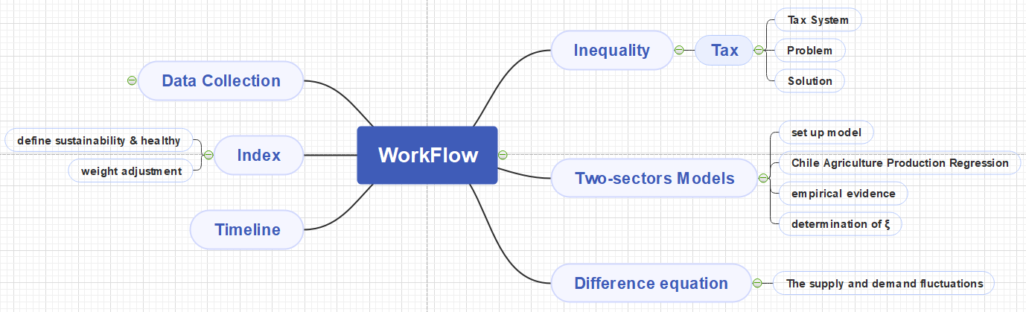

Figure Our Workflow Diagram

# Assumptions and Justifications

The following assumptions has been made base on our understanding to help further progress the discussion of this issue.

* **Model 1**

**Asmp1.** **All the data we used is updated.**

For some variable, we cannot find its updated version in 2020, but we think the data in recent 5 years is still persuasive.

* **Model 2**

**Asmp2. All the market in the Chile is perfect competition.**

This is a common assumption in economics. That means that all the cost of unit goods equal to unit price.

**Asmp3. The labor population distribution for different education background follows standard normal distribution.**

For a nation’s work force population, it is so large that we can reasonably assume that their human capital distribution is normalized.

**Asmp4. The human capital is determined by the experience of higher education.**

Under thisassumption, all the competition in labor market only considers whether the employees have obtained higher education.

**Asmp5. Labor is the only input we need to consider when we calculate production.**

By this model, we want to focus on how education influences funding and employment, by human capital and labor provided.

**Asmp6. The goods and human capital mobility are prohibited.**

Because two-sector model emphasize on explaining labor mobility between modern sector and traditional sector. If international flow is influential, the model needs to become much more complicated.

# Notations

The key mathematical notations used in this paper are listed in Table 1.

|  |  |  |
| --- | --- | --- |
| **Symbol** | **Description** | **Unit** |
| R | Resource | / |
| E | Environment | / |
| C | Connectivity | / |
| O | Output | / |
| $$φ_{sector}$$ | Production function | / |
| $$L\left( z<ξ\right)$$ | Total labor population without degree | / |
| $$z_{i}$$ | Human capital for i | / |
| $$ξ$$ | Threshold of $z_{i}$ | / |
| $$ω(z)$$ | Wage for worker with $z_{i}$ | / |
| $$C_{H}$$ | Unit cost of H | / |
| Y | GDP | $ |
| A | $$L\left( z>ξ\right)$$ | / |
| $$α$$ | The proportion of GDP on education expenditure | % |
| F | Average tuition fee | $ |
| P | Labor population | p |
| qd(t) | Demand at period t | / |
| qs(t) | Supply at period t | / |
| p(t) | Price at period t | / |

# Advanced Education Development Index [AED Index]:

## The Establishment of AED Index

To analyze the question, there are two main elements to focus on for education system, which are health and sustainability. Under health, many factors are taken into account such as opportunities equitability, research outcomes, international exchange and meaningful trainings. As for sustainability, funding and financial support is the main factor considered.

Merging the two elements, the AED index can be adopted to measure the relative conditions of higher education systems across different countries. After several literature review and data analysis, we interpreted the AED index and divided it into four parts: resources [R], environment [E], connectivity [C] and output [O].

|  |  |  |
| --- | --- | --- |
| Variables | | Description |
| R (30%) | R1 (10%) | Government expenditure on tertiary education as % of GDP (%) |
| R2 (10%) | R&D expenditure (% of GDP) |
| R3 (10%) | Expenditure on R&D in tertiary institutions (PPP) per head of population |
| E  (15%) | E1 (7.5%) | Qualitative index of the policy and regulatory environment |
| E2 (7.5%) | Gini index (World Bank estimate) |
| C  (10%) | C1 (5%) | international student ratio |
| C2 (5%) | collaboration article ratio |
| O  (45%) | O1 (2%) | total article number |
| O2 (5.5%) | total article per head of population |
| O3 (5.5%) | Average impact of articles |
| O4 (5.5%) | university ranking per head of population |
| O5 (5.5%) | Tertiary enrolment rates |
| O6 (5.5%) | Percentage of population over 24 with a tertiary qualification |
| O7 (5.5%) | Number of researchers in the nation per head of population |
| O8 (10%) | Ratio of employment rate of the tertiary educated compared with the non-higher educated |

The table provided above listed the variables, their descriptions, and their relative weight under the AED index analysis. The variables that are highly weighted are proportions that we identified to be more important factors; this decision of weight distribution are informed decisions based on several literatures.

Other improvements made includes:

Firstly, to further improve the relevance of results considering the different environments of comparing counties, we decided to add in the Gini Index for our AED index analysis. This will suggest us the degree of impact different income gaps can have on this study.

Secondly, for O4, its relevant data are collected and processed by using the Analytic Hierarchy Process (AHP) model to establish the weight of university ranking.



The result states that higher-ranking position should match a higher proportion.

## Application of AED Index

|  |  |
| --- | --- |
| COUNTRY | HED Index |
| Indonesia | 0.482 |
| Mexico | 0.605 |
| India | 0.801 |
| Chile | 1 |
| China | 2.024 |
| Japan | 2.902 |
| Germany | 4.681 |
| United States | 5.438 |
| United Kingdom | 6.985 |

To explore the current state of advanced education systems in each country, researchers have proposed a variety of measures to evaluate their performance. Here we picked several indexes to analyze:

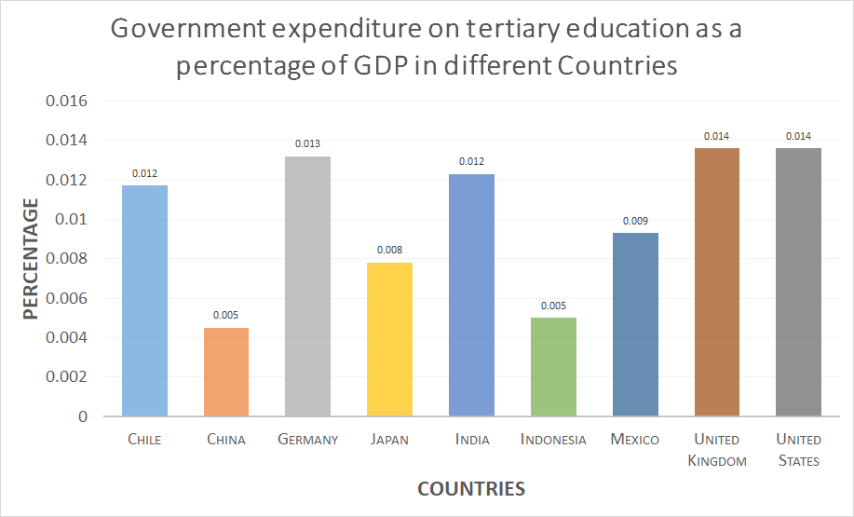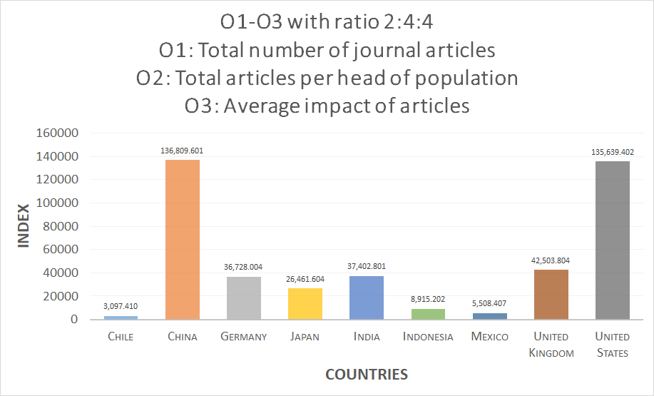By combining the data in the figure below with the AED index, we can find that countries with relatively high government funding have a higher AED index, which is in a proportional relationship. But Chile has an outlier outcome. Its government funding is high, but its AED index is a lot lower than its proportional relationship.

Figure & 3

In this chart, we use O1-total number of journal articles, O2-total number of papers per capita and O3-average influence of papers in ratio of 2:4:4 as indicators to measure national research capabilities. From the chart, we can clearly see that China and the United States have high O1-3 indexes. However, we found that China and the United States have a large gap in AED index. Furthermore, China is not ahead of other countries in terms of AED index. Therefore, it can be concluded that China’s O1-3 index is due to the large number of published articles but average quality. We have taken this into account when calculating the AED index. So, the weight of O1 is only 2% of the total weight.

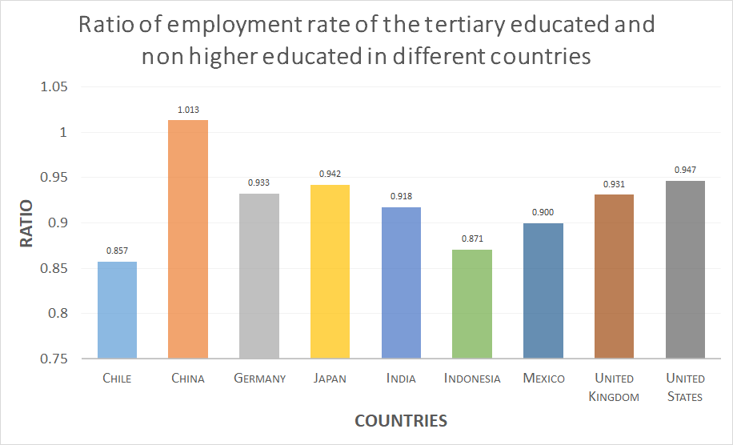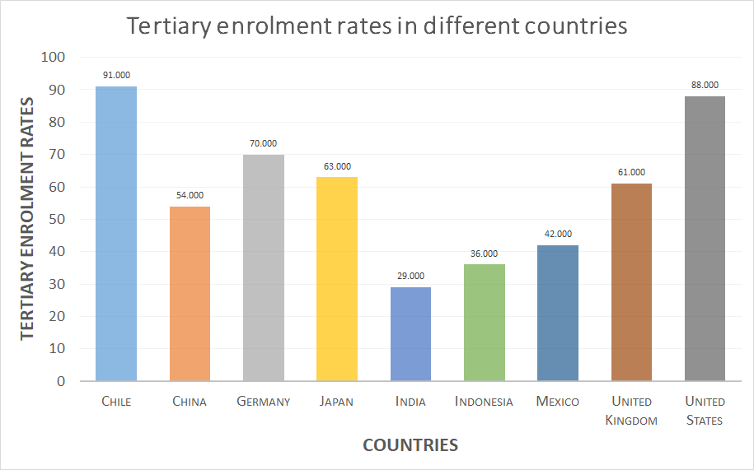Employment data is an important factor of measuring the suitability of education and training and whether it is useful to society. To highlight its importance, we adjust the weight of this indicator to be higher than other output indexes. In this regard, the best performing country is Asian countries, such as China and Japan. In the three countries of Chile, Mexico, and Indonesia, the employment rate of people who completed only secondary education is much higher than that of people with higher education, which may indicate that the higher education sector does not produce the required graduate mix that serves all sectors of the country.

Figure &

Chile has the highest tertiary enrolment rate among all the country followed by the United States. This result is surprising since Chile surpasses multiple first world countries such as Germany and the United Kingdom in terms of tertiary enrolment rates. China obtained a relatively high tertiary enrolment rate given that countries with similar population sizes such as India and Indonesia are lower in comparison.

# Two-sector Model

In this section, we will set up a two-sector model to provide a new higher education budget target for Chilean government, by considering labor force allocation between agriculture and manufacturing. Two-sector model, in economics, was introduced to analyze the flow of production factors between two sectors. For our own two-sector model, we assume the government can control national labor distribution in agriculture and manufacturing by funding universities and institutions, because the access to these two industries in our model tightly relate to higher education experience.

## The Establishment of Two-sector Model

First, we consider goods markets. In traditional sector $(L)$, the output has a positive relationship with labor. The production function in modern sector $(H)$ has a same character as that in traditional sector, but the marginal production per labor unit will be greater than that in traditional sector. It is reasonable that per worker with higher education experience is more effective in production. The Mathematical expression are written as:

$$\begin{aligned}{φ_{sector}}^{'}\left(l\right)>0\# AUTONUM \backslash * GB2 \end{aligned}$$

$$\begin{aligned}φ_{H}^{'}\left(l\right)>φ_{L}^{'}\left(l\right)\# AUTONUM \backslash * GB2 \end{aligned}$$

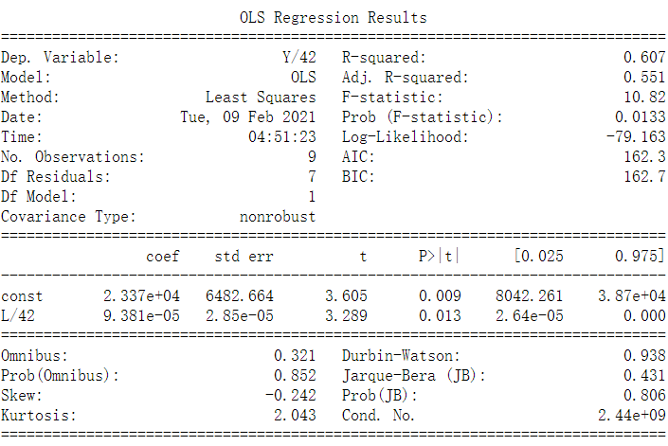The $φ_{L}\left(l\right)$ refers to the traditional production function; $φ_{H}\left(l\right)$ refers to modern production function. $l$ means the labor input amount in production. Based on Chilean data from 2010 to 2019, we fitted an agriculture production function with adjusted R-square value, 0.551, which can prove our expectation, but the data from manufacturing industry is extremely scattered, finding regression is impossible. This is because Chilean secondary industry GDP are dominated by primary manufacturing, such as mining, smelting, but, in this model, modern sector more focuses on high value-added industries which have strong relationship with human capital.

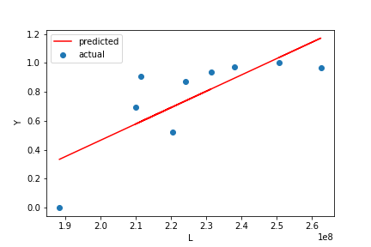

Figure & 7

Second, we can set a threshold $ξ$ to divide all employee into two parts. As the Assumption.3, the human capital distribution of labor force population is standard normal distribution, and $z_{i}$ reflects workers’ ability (see fig-8). $ξ$ is a threshold between traditional and modern sector. More skilled workers (right of $ξ$) will be allocated to the modern sector because their advanced education background can meet entry requirement, and vice versa. Besides, the movement of $ξ$ means the advanced education system’s achievement. The left movement means the number of well-trained workers increasing, and ‘output’ of universities increasing. Although the label of Y-axis is “labor”, Y-axis means the employee number at that level of human capital. The area under the function is the total number of labor force ($Φ\left(z_{i}\right)$) less or more skilled than $ξ$.

$$\begin{aligned}L\left(z_{i}<ξ\right)=\frac{1}{\sqrt{2π}}\int_{-∞}^{ξ}{e^{\frac{{-z_{i}}^{2}}{2}}dz_{i}} \# AUTONUM \backslash * GB2 \end{aligned}$$

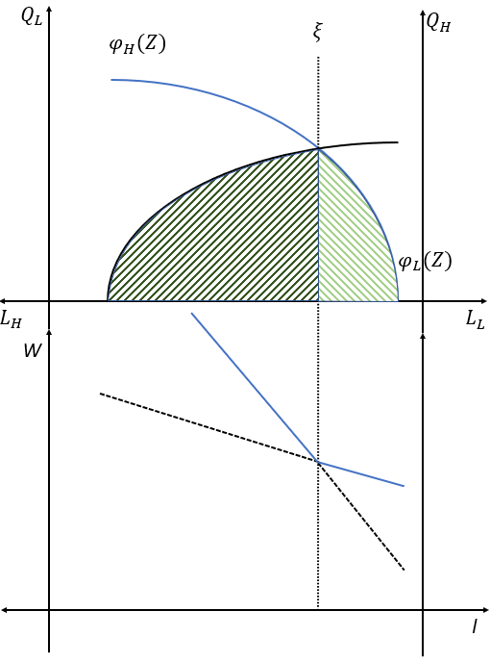

Figure

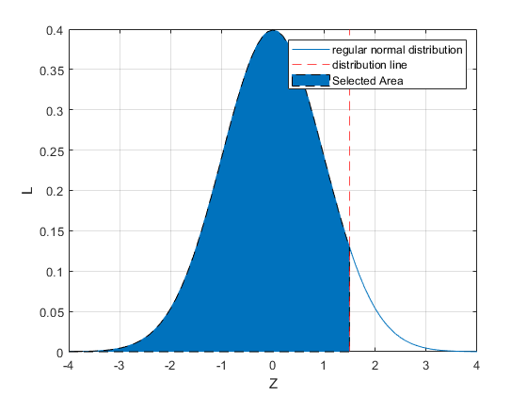

Figure

Third, according to $ξ$, the wage function ($ω\left(z_{i}\right))$ can be expressed. For simplicity, we define price of $H$ goods as $P$, $L$ goods as 1. In addition, in the perfect competition market, the unit price must equal to the cost of unit production, and in our model, labor is the only source of cost. Hence, when $z_{i}=ξ$, $ω_{H}=ω_{L}$, from formula：

$$\begin{aligned}P=C_{H}=\frac{φ_{L}\left(ξ\right)}{φ_{H}\left(ξ\right)} \# AUTONUM \backslash * GB2 \end{aligned}$$

Because of $φ_{H}^{'}\left(l\right)>φ_{L}^{'}\left(l\right)$,

$$\begin{aligned}φ_{H}\left(ξ\right){≫φ}_{L}\left(ξ\right): \frac{∂C_{H}}{∂ξ}>0 \# AUTONUM \backslash * GB2 \end{aligned}$$

$$\begin{aligned}φ_{H}\left(ξ\right){>\frac{φ_{H}^{'}}{φ_{L}^{'}}φ}_{L}\left(ξ\right): \frac{∂C_{H}}{∂ξ}<0 \# AUTONUM \backslash * GB2 \end{aligned}$$

$$\begin{aligned}φ_{H}\left(ξ\right){>φ}_{L}\left(ξ\right): \frac{∂C_{H}}{∂ξ}<0 \# AUTONUM \backslash * GB2 \end{aligned}$$

When a country has a developed manufacturing sector, the manufacturing sector has a relatively saturated labor supply. Therefore, decreasing labor supply leads to cost decreasing. The same situation will appear in agriculture sector when agriculture industry dominates the economy.

Because both two markets are assumed as perfect competition market, the sum of income equal to $Y=\int_{-∞}^{ξ}{φ_{L}}\left(z_{i}\right)f\left(z_{i}\right)dz_{i}+C_{H}\left(ξ\right)\int_{ξ}^{∞}{φ_{H}\left(z_{i}\right)}f\left(z_{i}\right)dz_{i}$. Therefore, to achieve society GDP maximization, we need to find the optimal value $ξ^{*}$ in the question:

$$\begin{aligned}MAX Y=\int_{-∞}^{ξ}{φ_{L}}\left(L\left(z_{i}<ξ\right)\right)dz_{i}+C_{H}\left(ξ\right)\int_{ξ}^{∞}{φ_{H}\left(L\left(z_{i}≥ξ\right)\right)}f\left(z_{i}\right)dz_{i} \# AUTONUM \backslash * GB2 \end{aligned}$$

$$s.t. 0<ξ<1$$

Further, in order to take account of time factor, we need to adjust some variable. The ratio of labor force with higher education experience is defined as

$$\begin{aligned}A=L\left(z_{i}≥ξ\right)=\frac{1}{\sqrt{2π}}\int_{-∞}^{ξ}{e^{\frac{{-z_{i}}^{2}}{2}}dz_{i}} \# AUTONUM \backslash * GB2 \end{aligned}$$

Then, the difference equation of A can be written as:

$$\begin{aligned}ΔA={\frac{αY_{t-1}}{F}}/P \# AUTONUM \backslash * GB2 \end{aligned}$$

Where $α$ is the percentage of advanced education expenditure to GDP； $Y_{t-1}$ is the last year GDP；*F* is average tuition fee of university students; *P* is population of university age.

By this change, we can gain $ξ_{t}$, then all the variables will be predicted. On the one hand, we can use this model to observe the process of system reach equilibrium and predict the time of this process; On the other hand, $α$ show the influence of the government’s budget, and the government can use this to determine a suitable higher education budget.

## The Solution of Model :

By finding $ξ^{*}$, we can maximize society output, and figure out the optimal labor force allocation of two sector. If the Chile can achieve this static equilibrium, their O9 of Advanced Education Development index will have a significant improvement. Besides, with the economic prosperity, the education expenditure to tertiary education will proportionally increase. However, this allocation potentially causes income inequality because different group workers have different income.

## Model Analysis

This model is a pure theoretical model, but as long as the government releasing data to the public, the feasibility can be tested. Besides, we still can find some empirical evidence to prove this model’s conclusion. Sylwester (2018) researched the Chilean relationship between income and education expenditure and achievement. He pointed out the strong relationship between productivity and education experience, which will lead to access higher income. In addition, the domination of primary manufacturing industry hinders other higher value-added industries’ development, which leads to a large amount labor force waste.

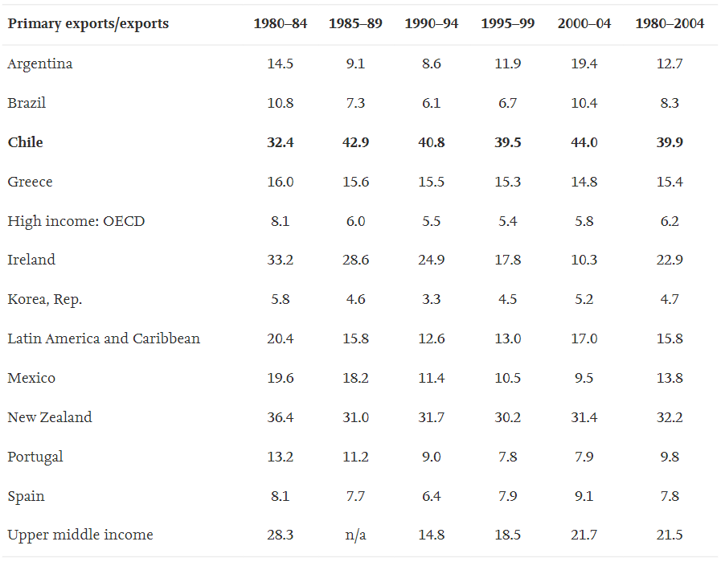

Figure

# The Difference Equation in Labor Market

## The Establishment of Two-sector Model

The reason why university students cannot find job, not only come from education system’s funding problem we discussed in the last model, but also the time gap between demand and supply changes and price adjustment. The third model will analyze why gap between demand and supply always change.

First, we write demand and supply functions as :

$$\begin{aligned}qd\left(t\right)=a-b*p\left(t\right), where a,b>0 \# AUTONUM \backslash * GB2 \end{aligned}$$

$$\begin{aligned}qs\left(t\right)=c+d*p^{^}\left(t\right), where c,d>0 \# AUTONUM \backslash * GB2 \end{aligned}$$

After that, because in the equilibrium, the supply should equal to demand, besides we use t-1 to predict the variable at t. Then, we gain:

$$\begin{aligned}p\left(t\right)= \frac{a-c}{b}-\left(\frac{d}{b}\right)*p\left(t-1\right)\# AUTONUM \backslash * GB2 \end{aligned}$$

We collected the Chilean manufacturing labor information from 2010-2019. Then, we did linear regressions to observe the relationships between wage and labor supply, and wage and labor demand:

$$\begin{aligned}Q_{d}=0.0069x + 133980 \# AUTONUM \backslash * GB2 \end{aligned}$$

$$\begin{aligned}Q_{s}=0.0165x-7576.3 \# AUTONUM \backslash * GB2 \end{aligned}$$

The r-squares of supply regression and demand regression are:

$$R_{d}^{2}=0.9563$$

$$R_{s}^{2}=0.8015$$

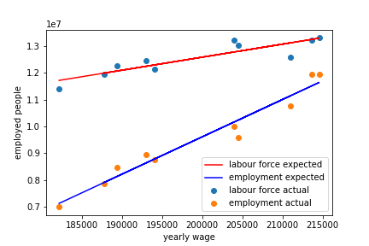

Figure

Because r-squares for the regression lines are greater than 80%. It could be considered as a strong evidence that the regression line could be accepted.

Generally, the intersection of labor supply and labor demand is the static equilibrium. But, in reality, people only can observe the wage in this period, instead of the gap between the labor supply and labor demand. This will lead to disordered oscillation around equilibrium point (Y*, Q*). To illustrate this dynamic process, we set a difference function to express the relationship between the P in this period (P(t)) and the P in the next period (P(t+1)). For the Chilean wage difference function, we gain:

$$\begin{aligned}p\left(t\right)= \frac{7576.3+133980}{0.0165}+\left(\frac{0.0069}{0.0165}\right)*p\left(t-1\right) \# AUTONUM \backslash * GB2 \end{aligned}$$

## The Solution of Model :

Use this difference function to observe the travel path of this P which can be influenced by the last period P, we found the fig-11. From this figure, we can find the P(t) is converging to the P*, and the fig-12, also can show this trend.

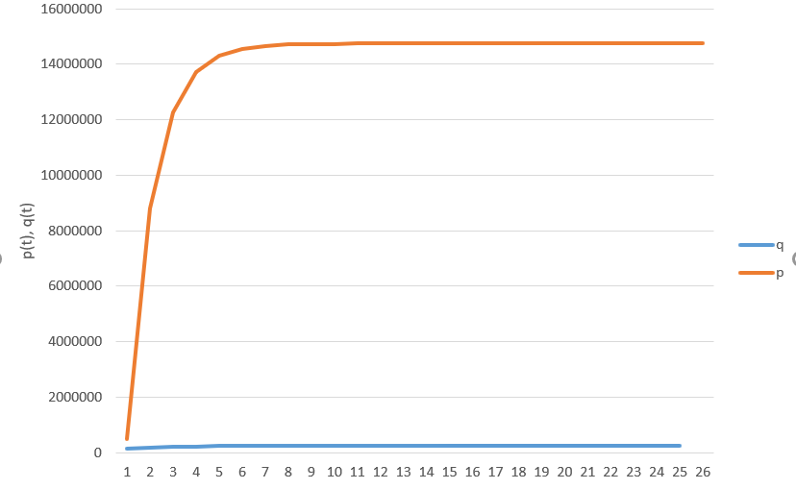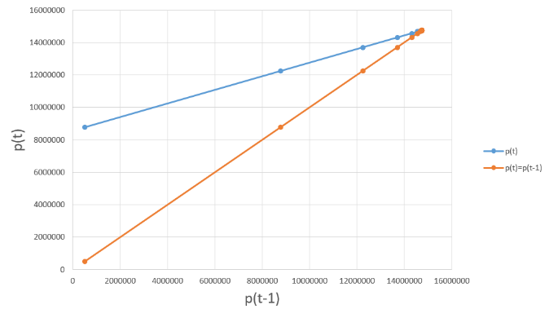

Figure &

However, on the other hand, when $\left|\frac{d}{b}\right|>1$, the equilibrium will impossibly be achieved, the path of P will diverge from P*.

## Model Analysis

This model can explain the existence the influence of time lag, especially in the labor market the skill training will take a long time, but the demand always changes easily.

# The Tax Policy

The second difficulty is inequity of higher education opportunity, but the essential of inequity of education access is inequitable wealth distribution. Although we see a high enrollment rate, 91%, in Chilean higher education system, in fact, most part of student from low-income family has be eliminated in secondary and primary school. 32.6% of dropout student comes from the lowest socio-economic status (Casen 2013). Besides, based on ‘s report, the biggest limit of human capital expansion is imbalance distribution of education investment. The education investment from private sector is four times greater than that from the public. This can also explain why Chilean R index (fig-7) is lowest, because the potential and qualified researchers are selected by family income rather than capacity for learning. Therefore, before we address education distribution imbalance, equity of income and wealth bears the brunt.

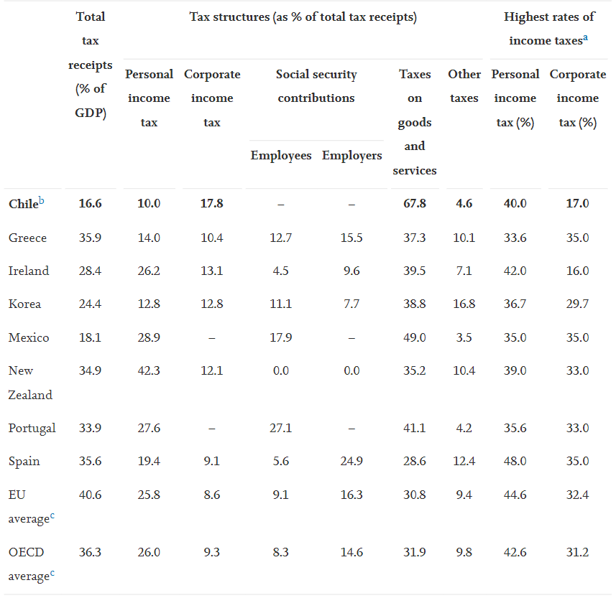

Figure

Compared with the OECD average total tax burden of GDP, that number for Chile is only 16% of GDP. Although the top personal income tax rate is high, 40%, the existence of loopholes in current tax system causes total personal income taxes only contribute to less than1.6% of GDP. Besides, the high levels of tax compliance also lead to large public profit flowing to the private sector.

To address the issue of flaws in Chilean tax systems, several suggestions can be made for Chile to carry out sound tax reforms that benefit the country as a whole. The current tax structure of Chile exists multiple loopholes and untaxed areas that creates a pro-elite society within the country (López & Miller 2008). The lack of tax policy that targets income and corporate revenue result in Chilean’s tax structure to accentuate its existing inequality instead of being its limiting factor.

The main obstacle of meaningful tax reform for the Chilean’s government is the threat towards the benefits of elites it poses. Tax policy that decreases equality provides more households spending power which improves economic growth in most cases (Biswas et al. 2017). Therefore, it can be argued that despite short term losses for elite, the appropriate tax reforms can help Chile remains its competitiveness in the world economy and gain new sustainable fields of economic growth when the demand of its population increases.

Currently, Chile’s tax structure focuses on utilizing Value-Added Tax (VAT) which is a consumption tax for each stage of value adding from production to sale. VAT system result in evasion and lack of tax obligation in Chile at an estimated of 23% taxation not being upheld (Engel et al. 1999).

To prevent loopholes and create a taxation policy that the country’s fiscal system can effectively implement, we recommend Chile to adopt the Alternative Minimum Tax (AMT) policy that United States has implemented within its country. AMT disregards any deductions that taxpayer can claim to pay a fix amount of tax to the government, its adoption is fundamental towards progressive tax with minimal distortion to the market (Hines & Logue 2014). The nature of AMT’s requirement of a certain level of minimal payment ensures that the Chilean’s government will have a steady projection for future tax revenues. The simplicity in its requirements makes its tax obligation hard to ignore and escape for the top income elites of Chile. Furthermore, it can be flexible by adopting different rates for varying level of income, restricting the growth of inequality within the country.

# Implementation Timeline

Through above models, we have already analyzed the higher education system and found out some problems. To improve current education system, we make a combination of policy and arrange a timeline.

Firstly, we think Chile should reform their tax system. The obsoleted taxation system contributes the inequitable wealth distribution, which has discussed in the fourth model in detail. Moreover, the Pandemic aggravate this inequity. Deloitte research states that there exists gap between high-, medium-, and low-wage occupations in Chile (Barua & Buckley 2019).Some occupations and industries are restricted by the government regulation: social distance and lockdown, and these kinds of occupations and industries are in the recission status, among 22 major occupations fell by 40% due to the pandemic (Barua & Buckley 2019). Compare to the low-income wage group, high income level group are not affected much, and it directly widen the gap between different income groups. Therefore, we suggest Chile to revolute their taxation system, then the government could have enough budget and fully prepared for the next implementation. Obviously, this policy will suffer the impugnment from rich people, but this will be the first step to fair society.

Secondly, by funding money from the revolution of tax system, the government can have sufficient financial budget to invest higher education and industries. We have discussed how to allocate human capital to achieve the most optimal economic output. After that, the overall industry structure has been changed, this nation has turned from agricultural to industrial country. Admittedly, in the short term, the agriculture population face a large scale of unemployment, but this labor will be absorbed by the manufacturing sectors. Changing in the industrial structure means this nation would be better performed in GDP. With the popularization of higher education, the industry structure becomes more effective, and the nation could successfully achieve the sufficient employment.

Finally, we need to consider reality situation- the time lag of the employment market. Because training a skilled work force takes a long time, or the growth of a new industry takes long time. During this period, the labor market, demand greater or less than labor supply is a common phenomenon. Therefore, in the process of human capital structure adjustment, many graduations will face temporarily be unemployed and earn low income.. To prevent this market failure, we suggest that government should monitor the changes from both supply and demand side of the labor. Furthermore, government should also control the higher educated human capital structure.

All above these suggested implementations are aimed to keep the sufficient employment and help Chile achieve a healthy and sustainable higher education system.

# Model Evaluation and Further Discussion

## Strengths

* Consideration of dynamic process. The second and third models introduced difference equation, so these models can follow the change happened in the system. Additionally, because of that, the exogenous variables can be transferred to endogenous variables.
* Achievement of multi-targets. The second model can achieve GDP maximization, financial budget determination and labor allocation.
* Simplicity. The AED index is brief, which avoid a lot of problems brought by data over-processing.

## Weaknesses

* Indirectness. Although our policy recommendation is useful, but our policy indirectly relates to higher education system.
* Incomprehensiveness. The second model, we did not discuss the labor mobility.

## Further Discussion

We did an excellent work in this contest. We built up the relationship between economy development and higher education outputs and provide an economics explanation of fluctuation in Chile labor market.

In the future, we think the influence of immigration between different countries in education system and labor market is also meaningful. In addition, in this contest, we just focus on the economics meaning combine with mathematical models of higher education system, but the perspectives from Psychology, sociology could also be an interesting direction.

# References

Biswas, S., Chakraborty, I. and Hai, R. (2017). Income Inequality, Tax Policy, and Economic Growth*. *The Economic Journal*, 127(601), pp.688–727.

Chinchilla-Rodríguez, Z., Sugimoto, C.R. and Larivière, V. (2019). Follow the leader: On the relationship between leadership and scholarly impact in international collaborations. *PLOS ONE*, 14(6), p.e0218309.

data.worldbank.org. (2019). *Research and development expenditure (% of GDP) | Data*. [online] Available at: https://data.worldbank.org/indicator/GB.XPD.RSDV.GD.ZS.

data.worldbank.org. (n.d.). *Researchers in R&D (per million people) | Data*. [online] Available at: https://data.worldbank.org/indicator/SP.POP.SCIE.RD.P6?end=2018&start=2018&view=map [Accessed 6 Feb. 2021].

data.worldbank.org. (n.d.). *School enrollment, tertiary (% gross) | Data*. [online] Available at: <https://data.worldbank.org/indicator/SE.TER.ENRR>.

Demekas, D.G. (1990). Labor Market Segmentation in a Two-Sector Model of an Open Economy. *Staff Papers - International Monetary Fund*, 37(4), p.849.

Little, D. (1995). Economic Models in Development Economics. *On the Reliability of Economic Models*, pp.243–273.

Hines, J.R. and Logue, K.D. (2014). Understanding the AMT, and Its Unadopted Sibling, the AMxT. *Journal of Legal Analysis*, 6(2), pp.367–408.

López, R. and Miller, S.J. (2008). Chile: The Unbearable Burden of Inequality. *World Development*, 36(12), pp.2679–2695.

Oecd.org. 2021. *OECD*. [online] Available at: <https://www.oecd.org/education/education-at-a-glance-19991487.htm/?refcode=20190209ig> [Accessed 6 February 2021].

Our World in Data. (n.d.). *Government expenditure on tertiary education as share of GDP*. [online] Available at: https://ourworldindata.org/grapher/government-expenditure-on-tertiary-education-as-share-of-gdp?tab=table [Accessed 6 Feb. 2021].

Saint-Paul, G. (2004). Are intellectual property rights unfair? *Labour Economics*, 11(1), pp.129–144.

Statista. 2021. *Chile - Employment by economic sector | Statista*. [online] Available at: <https://www.statista.com/statistics/370372/employment-by-economic-sector-in-chile/> [Accessed 6 February 2021].

Statista. 2021. *Chile - share of economic sectors in the gross domestic product 2019 | Statista*. [online] Available at: <https://www.statista.com/statistics/370021/share-of-economic-sectors-in-the-gdp-in-chile/> [Accessed 6 February 2021].

Vučković, V. (2014). Justin Yifu Lin: New Structural Economics: A Framework for Rethinking Development and Policy. *Croatian Economic Survey*, 16(1).

Worldbank.org. (2017). *GINI index (World Bank estimate) | Data.* [online] Available at: https://data.worldbank.org/indicator/SI.POV.GINI?most_recent_value_desc=false&view=map.

World Population Prospects United Nations World Data Booklet. (2015). [online] . Available at: <https://population.un.org/wpp/Publications/Files/WPP2015_DataBooklet.pdf>.

www.oecd-ilibrary.org. (n.d.). *Educational attainment of 25-64 year-olds (2018): Percentage of adults with a given level of education as the highest level attained*. [online] Available at: https://www.oecd-ilibrary.org/education/educational-attainment-of-25-64-year-olds-2018_fa820f6e-en [Accessed 6 Feb. 2021].

www.oecd-ilibrary.org. (n.d.). *Education at a Glance 2020: OECD Indicators*. [online] Available at: https://www.oecd-ilibrary.org/education/education-at-a-glance-2020_69096873-en [Accessed 6 Feb. 2021].

www.scimagojr.com. (n.d.). SJR - *International Science Ranking.* [online] Available at: https://www.scimagojr.com/countryrank.php?year=2019 [Accessed 6 Feb. 2021].

www.shanghairanking.com. (n.d.). *Statistics of Academic Ranking of World Universities - 2020*. [online] Available at: http://www.shanghairanking.com/ARWU-Statistics-2020.html#2 [Accessed 6 Feb. 2021].

TheGlobalEconomy.com. (n.d.). *Regulatory quality by country, around the world*. [online] Available at: https://www.theglobaleconomy.com/rankings/wb_regulatory_quality/.

Tradingeconomics.com. (2019). *India GDP*. [online] Available at: https://tradingeconomics.com/india/gdp.

Tradingeconomics.com. 2021. *Chile - Employment In Agriculture (% Of Total Employment) - 1975-2020 Data | 2021 Forecast*. [online] Available at: <https://tradingeconomics.com/chile/employment-in-agriculture-percent-of-total-employment-wb-data.html> [Accessed 6 February 2021].

Yang, J and Tian, S.T (2018). The government's optimal expenditure structure in education in the two-sector production model: Taking Beijing as an example. *Educational Economics Review*, [online] (5). Available at: http:// jyjjpl.bnu.edu.cn/ch/reader/view_abstract.aspx?file_no=20180502&flag=1 [Accessed 8 Feb. 2021].

Yeaple, S.R. (2005). A simple model of firm heterogeneity, international trade, and wages. *Journal of International Economics*, 65(1), pp.1–20.

# Appendices

|  |
| --- |
| Appendix 1 |
| Introduce: Implementation of AHP algorithm |
|  |

|  |
| --- |
| Appendix 2 |
| Introduce: Implementation of Regression |
|  |

|  |
| --- |
| Appendix 3 |
| Introduce: Timeline visualization |
|  |